**Week 3**

**Watson Studio**

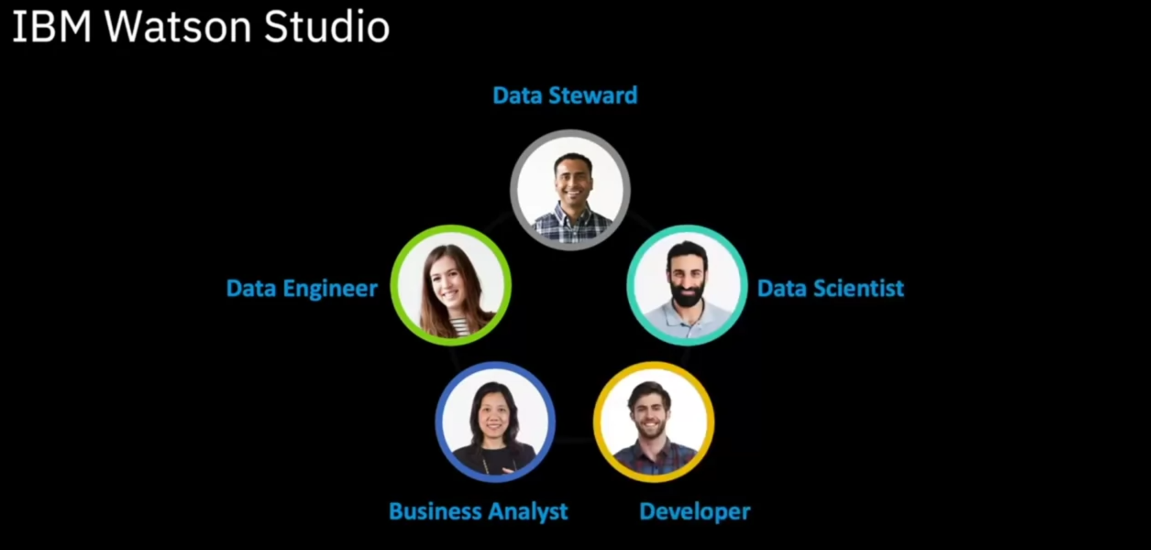

**Other IBM Tools**

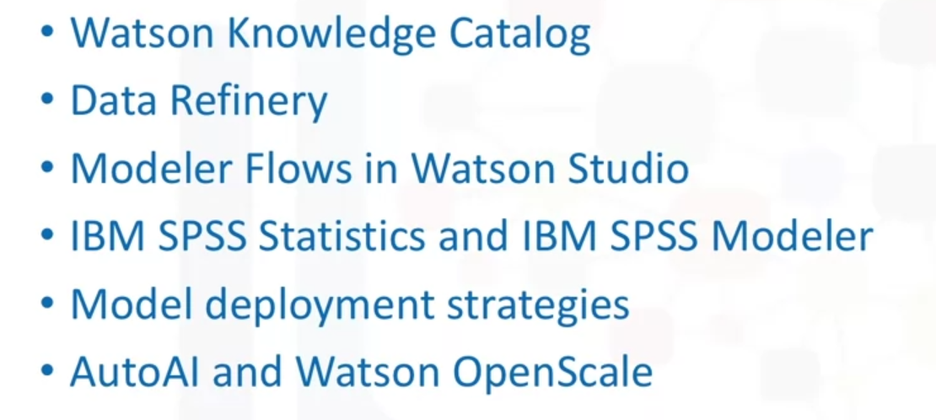

* Watson Knowledge Catalog helps data scientists to catalog and manage all their data resources.
* Data refinery provides graphical tools for analyzing and preparing data.
* SPSS based products include easy to use graphical interfaces for wide varieties of statistical and machine learning algorithms and data transformations.
* We will talk about approaches to model deployment, including open standards and Watson Machine Learning.
* Newer features of Watson Studio include AutoAI that automatically computes the best data pipeline and Watson OpenScale which helps to ensure fairness and explainability of the models.

Watson Knowledge Catalog

